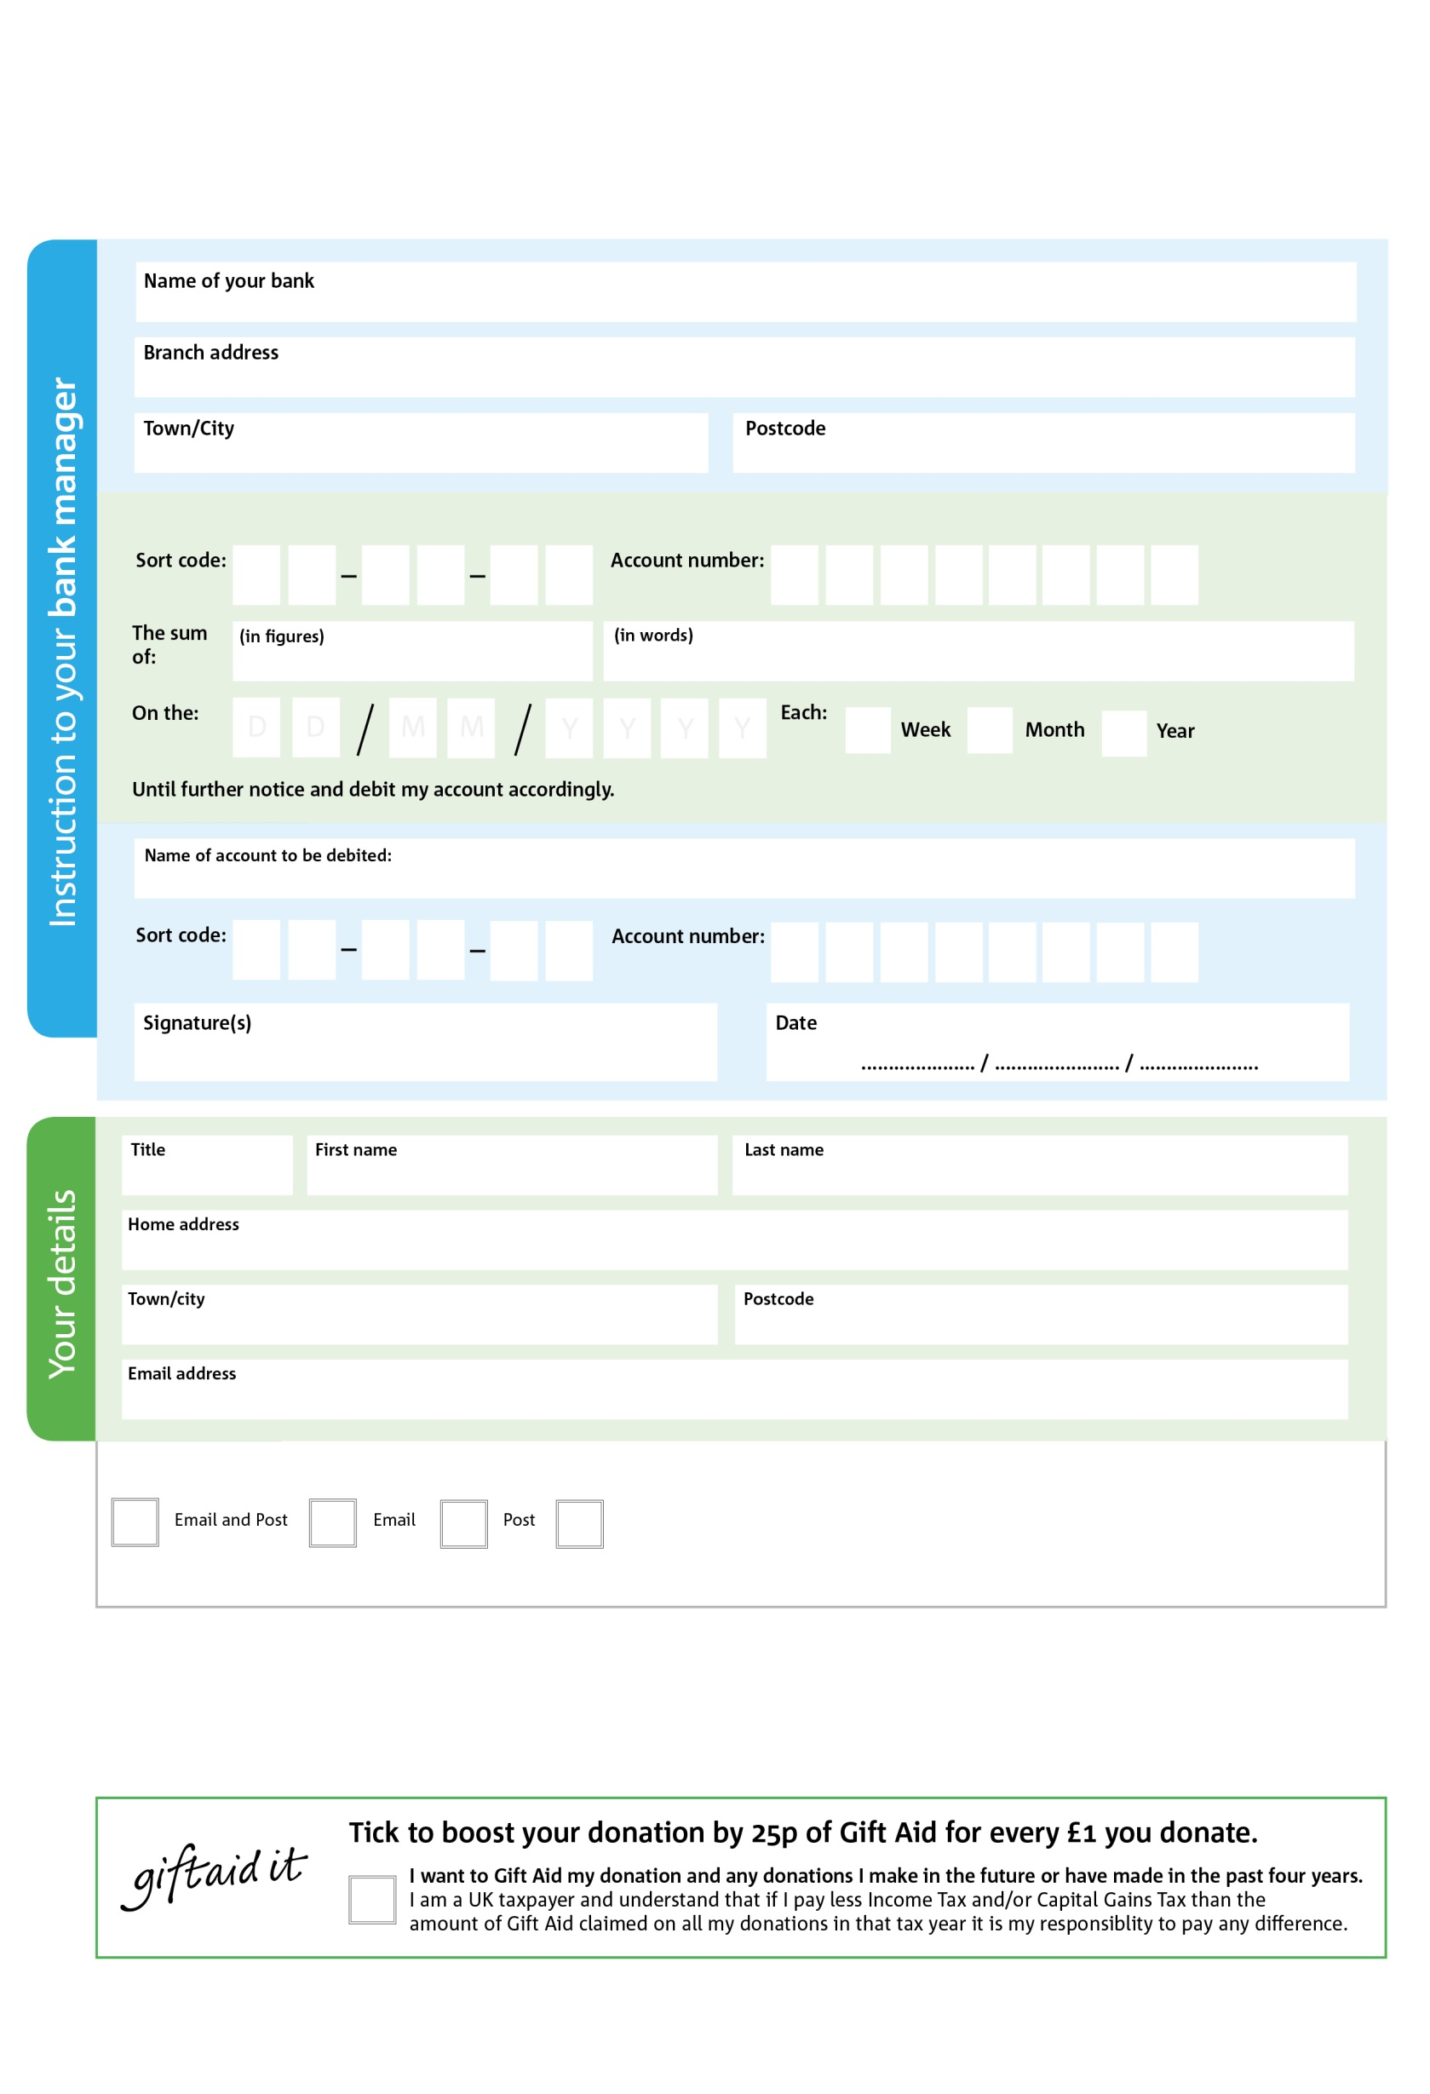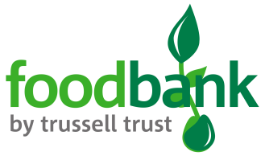

Reg. Charity No: 1128607 | Reg. in England & Wales

Please pay Sherwood Forest Foodbank,

**Standing Order Mandate**

**Sherwoodforest.foodbank.org.uk**

POSTAL ADDRESS: Sherwood Forest Foodbank, [The Stable Centre Church St, Mansfield NG19 9JY](https://www.bing.com/local?lid=YN1029x9590904630137345043&id=YN1029x9590904630137345043&q=Sherwood+Forest+Food+Bank&name=Sherwood+Forest+Food+Bank&cp=53.16434860229492%7e-1.1890599727630615&ppois=53.16434860229492_-1.1890599727630615_Sherwood+Forest+Food+Bank)

7

V

4

V

7

V

6

V

5

V

1

V

8

V

5

V

**Please pass this form onto the foodbank, using the foodbank’s address at the bottom, who will save a copy for their records.   
They will then send it onto your named bank or building society.**

3

0

4

1

0

6

We would love to keep you up to date with information about Sherwood Forest Foodbank. Please tick your preference:

You can change your preferences any time by contacting us on 07563 233652 or emailing us at [info@sherwoodforest.foodbank.org.uk](mailto:info@sherwoodforest.foodbank.org.uk)

I do not wish to receive future communications from Sherwood Forest Foodbank

**Data protection**

*'Sherwood Forest Foodbank is committed to protecting your privacy and will process your personal data in accordance with current Data Protection legislation. Sherwood Forest Foodbank collects information to keep in touch with you and supply you with information relating to our work. To unsubscribe from our newsletter, send a message to the email address above with the word unsubscribe in the subject line. A full data privacy statement for financial donors is available from the foodbank on request.’*

You can change your preferences any time by contacting us on XXXXXXXXXXX or emailing us at XXXX@XXXXXXXXXX.foodbank.org.uk

I do not wish to receive future communications from XXXXXX Foodbank